Tab 1

Smart Refrigerator

Isabel Price, Kalino Ruiz, Matthew Manuel, Brent Marin, Caleb Mok

Advisor/Instructor: Dr. Keith Yi, Technical Advisor: Sargon Ishaya

Me195a Senior Design Project I, Section 02

San José State University

Charles W. Davidson College of Engineering, Mechanical Engineering Department

5/12/2025

# Executive Summary

For our senior design project, we are retrofitting a mini refrigerator with a passive cycle designed to save money through avoiding energy consumption during peak hours. We designed a passive cooling system that fits into a preexisting mini refrigerator’s freezer compartment with a fan that blows air over an assembly of ice packs and heat sinks, which was optimized using a custom spreadsheet. The ice will freeze during the traditional active vapor compression refrigeration cycle. Then, our microcontroller will turn off the active cycle during peak hours and instead run only the passive cooling fan, which consumes less power while still maintaining the refrigeration chamber at a safe temperature of 37 degrees Fahrenheit.

Our major findings include that during the passive cooling period, our average cooling load is 51 W, we require at least 109 cubic inches of ice to maintain temperature, and the passive cooling fan must provide an average of 60 cubic feet of air per minute. We also determined that the optimal heat sink configuration will have a surface area of 1.34 square meters after comparing several options. Finally, we determined that the current annual cost of operating the active cycle during peak hours is $20.49, which is greater than the cost after adding the peak-shifting passive cooling system, $17.14. This is a 16% cost savings per year.

# Acknowledgements

Firstly, we would like to acknowledge the support we have received and give a huge thanks to our Advisor, Dr. Keith Yi. Dr. Yi has been responsive and provided helpful feedback on our design decisions and calculations throughout the semester. His feedback has been invaluable and paramount to our success.

Next, we would like to thank Professor Hussameddine Kabbani. Professor Kabbani offered his expertise and advice at the very early stages of the project, which ultimately led to us choosing and developing the Smart Refrigerator concept.

Finally, we would like to thank Professor Sargon Ishaya for his advice in the final stages of our design and calculations, as well as his offer to provide additional input as our technical advisor next semester. As a professor of the HVAC course at SJSU, Professor Ishaya’s knowledge and expertise in refrigeration systems are greatly valued as we begin the controls and fabrication of the refrigerator.

**Table of Contents**

Executive Summary 2

Acknowledgements 3

List of Figures 5

List of Tables 6

Section 1.1- Problem Definition 7

Section 1.2- Project Objectives 8

Section 1.3- Project Specifications 9

Section 1.4- Literature and State-of-the-Art Review 12

Section 1.5- Codes, Standards, and Design Constraints 14

Section 1.6- Team Work Plan 15

Section 2.1 - Prime design concept 16

Section 2.2: Alternate concepts considered 19

Section 2.3: Concept Selection 21

Section 3.1 - Theoretical Background 23

Section 3.2 – Analysis 26

Section 4.1 – Documentation 32

Section 4.2 - Bill of Materials and Cost Analysis 34

References 37

‌Appendix A: Detailed Calculations 38

Appendix B: Detailed simulation results and computer programs 42

Appendix C: Detailed design Drawings 43

Appendix D: Excerpts from datasheets of components 46

Appendix E: Customer Needs Survey 47

# List of Figures

Figure 1: Trend in electricity cost in the United States 7

Figure 2: Residential Time of Use rate plan from PG&E 8

Figure 3 - Air Temperatures at Evaporator and Condenser 10

Figure 4 - Instantaneous load vs time of day 12

Figure 5 - CCRC Passive Cycle Prototype Schematic (Garber-Slaght, 2013) 13

Figure 6 - Trane Collaboration Peak/Off-Peak Cooling System 14

Figure 7 - Final design - Control Panel Layout 16

Figure 8 - Final Design - Heat sink and ice assembly 17

Figure 9 - Final Design - Freezer layout: Fan placement, vanes, and airflow direction 18

Figure 10 - Final Design - Mini refrigerator with shelves, drawer, and freezer compartment modifications 18

Figure 11 - Final Design - Return Duct 19

Figure 12 - Fin/Block Placement 20

Figure 13 - Control Panel placement 20

Figure 14 - Freezer Design Concepts 21

Figure 15 - Path of airflow for passive cooling cycle 26

Figure 16 - Simulation results plotted for chosen heat sink 29

Figure 17 - System and Fan Pressure Curve 30

Figure 18 - Drawing of Ice Block and Fin Setup 32

Figure 19 - Drawing of Vane and Wing Setup for Fan 33

Figure 21 - Draft of Refrigerator Circuit Diagram 34

Figure 22 - Loss coefficient due to expansion and contraction 38

Figure 23 - Loss coefficient due to bends 39

Figure 24 - Drawing of Ice Block and Fin Setup 43

Figure 25 - Drawing of Vane and Wing Setup for Fan 44

Figure 26 - CAD model of Vanes and Wings with Fan Visualization 45

Figure 27 - Fan performance sheet 46

## 

# 

# List of Tables

Table 1 - Pugh Matrix for Heat Transfer Shapes 22

Table 2 - Thermal entry length. 24

Table 3 - Example output table from heat sink simulation spreadsheet 28

Table 4 - Simulation results for chosen heat sink 29

Table 5 - Pressure Drop Calculations 31

Table 6 - Bill of Materials 35

Table 7 - Nusselt number depending on flow condition 38

Table 8 - Nusselt number for constant surface temperature given width a and height b 39

Table 9 - Water, ice, and air properties 39

Table 10 - Shell surface area and heat transfer through walls calculation 40

Table 11 - Inputs and preliminary calculations for heat transfer simulation spreadsheet 41

Table 12 - Customer Needs Survey 47

### 

# 

# Section 1.1- Problem Definition

Energy is a fragile resource. Energy production is highly variable, depending not only on natural/renewable resources present in a country, but also on global trade. War, economic recession, and trade disputes can all affect a country’s ability to procure energy. Thus, it is no surprise that energy is one of the first things to increase in price when things go awry on the global stage. For instance, from February 2022 to August 2022, average electricity costs in America rose from $0.15/kWh to $0.164/kWh due to the war in Ukraine, significantly outpacing already high inflation. The trend in electricity cost in the United States is shown below in Figure 1 as provided by the Federal Reserve Bank of St. Louis.

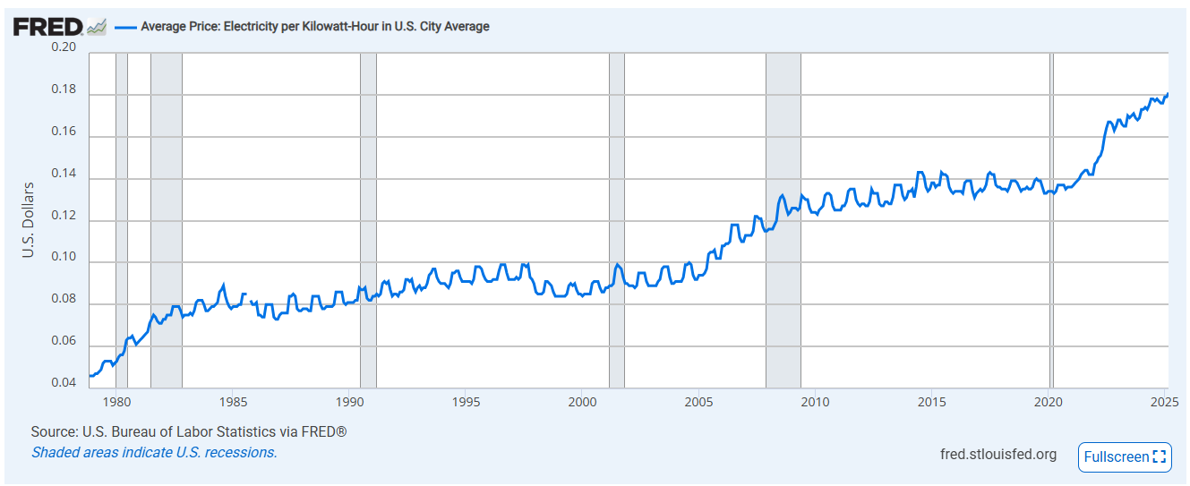

## Figure 1: Trend in electricity cost in the United States

California has the second-highest energy rates in the US, only behind Hawaii. Monthly utility bills have outpaced inflation by $15-20 since 2015 ([McGhee, 2025](https://www.ppic.org/blog/a-closer-look-at-californias-surging-electricity-rates/#:~:text=California%20has%20long%20had%20high,over%2080%25%20higher%20last%20year.)). While there are several reasons for this, the result is the same: energy is expensive, and this expense weighs much heavier on those who are worse off. The simple fact is that, when compounded with the high cost of housing and food due to inflation, lower-income Americans are likely to miss out on a meal or two if it means they can keep the lights and heat on (Luna, 2023). While not as much of an issue in California as little heating is required, our high cost of housing means that any compounded energy costs are especially damaging.

Refrigerators are non-negligible energy end-users. Refrigerators generally use 5% or more of daily household energy usage, and run 24/7 (EIA, 2018). While the electricity cost of refrigerators is highly variable, usually the cost runs between $50 and $150 a year. This cost is rather significant for an essential item that almost every household needs, so our team decided that creating a fridge that will offer energy cost savings was the ideal route. We decided to achieve energy cost savings through the use of load shifting from peak to off-peak with the use of thermal mass and a secondary passive cooling system. The cost of electricity is much higher during peak hours when there is a higher demand for electricity. This can be seen in the PG&E time-of-use rate schedule for residential households in Figure 2.

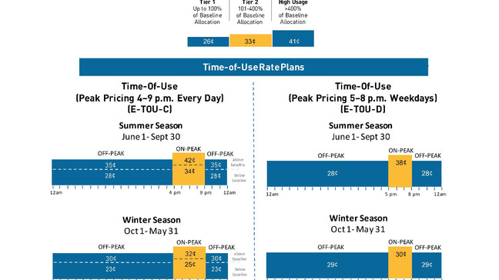

## Figure 2: Residential Time of Use rate plan from PG&E

# Section 1.2- Project Objectives

This project had two main objectives. The first objective was to keep our refrigerator at a safe temperature for food storage. After doing some background research, we concluded that the temperature we would maintain for our refrigerator at 37 degrees Fahrenheit. Our second objective was to save money through avoiding energy usage during peak hours of our chosen example rate schedule: 5 PM to 8 PM. The way we plan to save money is through utilizing a passive cycle that will operate during the peak hours, while the traditional active refrigeration cycle will be turned off. This technology differs from prior work as there are no currently available refrigerators that utilize thermal mass as a method of shifting load from peak to off-peak hours to save the consumer money.

The main principles of our project revolve around thermal mass conservation and refrigeration cycles. Our passive cycle will consist of casings of ice with heat sinks attached, the ice will freeze while the active cycle runs. Once peak hours hit, a fan will turn on and blow air over the ice casings to keep the contents of the fridge at 37 degrees Fahrenheit. Our plan is to take an existing minifridge and build the passive cycle using as many original components as possible.

# Section 1.3- Project Specifications

*Space constraints*

A big specification for our project is the temperatures of the refrigerant and air utilized in our active cycle. This is because these temperatures ultimately determine how low an internal temperature we can set in our fridge. For example, if we designed our refrigerator with unreasonably low ambient temperatures, it would make it much easier for the components like the condenser to reject heat. On the other hand, if we base our design on unreasonably high ambient temperatures, it is likely we will be designing for oversized components. Luckily, we will be utilizing a used mini fridge with components pre-engineered to achieve our desired internal temperature even on hot days. With this in mind, we have done research into average values for these temperatures, and because we do not currently have the fridge in possession, we will experimentally test these values in the fall to confirm if the components will work even with an altered interior design.

*Active Refrigeration Cycle*

To illustrate our natural convection refrigeration cycle, we have inserted the figure below with the air temperatures entering and exiting the coils.

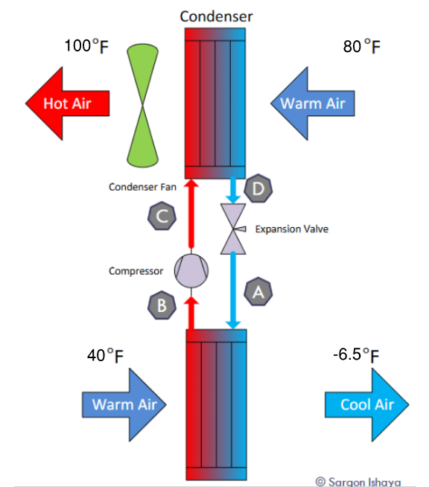

## Figure 3 - Air Temperatures at Evaporator and Condenser

Figure 3 takes into account our researched average internal temperatures at the evaporator as well as the temperature of air entering the condenser on a hot day in San Jose. To further describe the figure, we have come to the conclusion that the refrigerant at points A and B will be around negative twenty degrees Fahrenheit, and at points C and D will be around one hundred and twenty degrees Fahrenheit. We are well aware that these temperatures will remain remotely constant through the coils because of the fact that during a phase change, temperature will remain constant.

To reiterate our limitations, we are constrained to the size of the fridge we select because of the pre-engineered components, which were created with those dimensions in mind. This is a big reason why we chose to use our freezer section for our passive cycle.

*Simulated Grocery Load*

To act as a basis for the sizing of our passive cooling cycle, we simulated the load on the refrigerator during a typical day. There will be a constant load due to the small amount of heat transfer through the refrigerator’s walls, as there is a temperature difference between the refrigerated chamber and ambient room temperature. This constant load was determined to be approximately 49W. The detailed calculations can be found below in Table 10 in Appendix A. The other potential sources of heat entering the refrigerator are the opening and closing of the door, as well as room temperature items being added to the storage chamber.

We simulated the items being added to the refrigerator as cans of room-temperature water that are added throughout the day. The large spikes are simulated 5 cans of water and fall at typical times that consumers would interact with their refrigerator, such as lunchtime and evening time. The smaller spikes are simulated with a single can and are scattered throughout the day to resemble a shorter refrigerator interaction. Though we didn’t simulate the refrigerator door being opened using fluid dynamics calculations, we overestimated the load using the cans of water to account for the additional energy loss. The resulting instantaneous load in kW vs the time of day can be found below in Figure 4. We then averaged the instantaneous load during the passive cooling period from 5 pm to 8 pm in the evening to find an average load of 51 W.

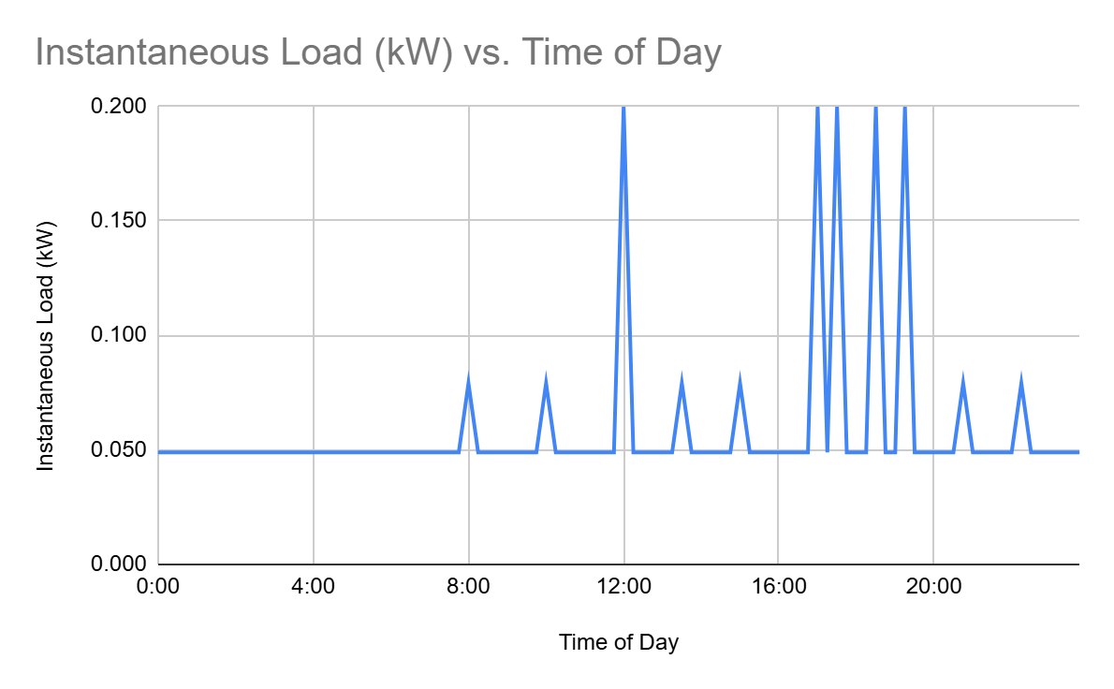

## Figure 4 - Instantaneous load vs time of day

# 

# Section 1.4- Literature and State-of-the-Art Review

From our background research, our group could not find any examples of people attempting to retrofit or create a refrigerator of any size with both an active and a passive cycle. Using a passive cycle and thermal mass is a simple method of cooling, as they are essentially ice chests. Ice chests were very common up until the 1930s and relied heavily on good insulation and an ice supply to keep food cold and safe. Ice chests were very successful at keeping things cold, but were eventually replaced by refrigerators with the modern vapor compression cycle.

However, we were able to find examples of the theory of thermal mass being applied. In 2013, the Cold Climate Research Center (CCRC) developed a refrigerator in Alaska that had fins that were affixed to the condenser coils and ducted outside to take advantage of the freezing cold air and wind, and cool the refrigerant down as depicted in Figure 5. It also had the traditional vapor compression cycle, but the CCRC was able to control how much it ran, and for the sake of testing, they had the compressor run at a very low setting. Attached below is a figure of the prototype. This model proved to be very effective during the winter months, consuming only 6.3 kWh with the passive model compared to 36.1 kWh over the same period of time with the active refrigeration cycle (Garber-Slaght, 2013).

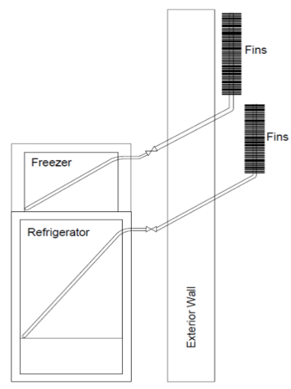

## Figure 5 - CCRC Passive Cycle Prototype Schematic (Garber-Slaght, 2013)

Another example of thermal mass being applied is a collaboration project between the HVAC equipment manufacturers Trane, Natgun, Ice Energy, and Calmac to develop a large-scale on/off peak cooling system for a building. The way this system worked is that during off-peak hours, the building’s chillers would chill water for the cooling coils, but also send some of the chilled water into a large tank. The large tank would be filled up before peak electricity rates hit. Once the peak hours hit, the chillers would turn off, and a valve would close, cutting the chillers off from the loop, so that the large tank supplies the cooling coils with cold water, then cycles back to the tank. A comprehensive diagram is listed below in Figure 6.

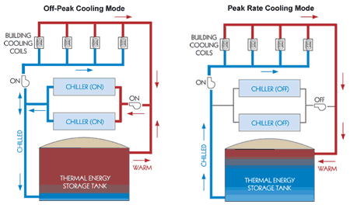

## Figure 6 - Trane Collaboration Peak/Off-Peak Cooling System

This system is very effective at reducing carbon dioxide emissions, energy consumption, and saving its clients money. This type of system was installed in a building in New York about 10 years ago. According to an article from Trane’s website, the 11 Madison Avenue building saved 1.4 million pounds of Carbon Dioxide emissions and a 25% reduction in central plant kilowatt-hour consumption. In addition to this, the building had a 10% reduction in tenant energy costs and saved more than “$730,000 annual building energy- and operating-cost savings, while reducing the strain on the electric grid” (Suitable Transformation…, 2024). Trane plans on continuing to develop this peak/off-peak cooling system and install it in more buildings.

# Section 1.5- Codes, Standards, and Design Constraints

Codes and standards that are relevant to our technical field include safe refrigeration internal temperatures to prevent foodborne illnesses. The United States Food and Drug Administration, or FDA, has made it clear that foods that require cold preservation should be stored at temperatures under 40 degrees Fahrenheit. This is because bacteria thrives at temperatures higher than this and is why we will design our refrigerator to maintain an internal temperature of 37 degrees Fahrenheit.

Another code and standard that is constantly changing and updating with time is the type of refrigeration we can use. The refrigerant that our desired mini fridge uses is R-134a, and luckily, it is still on the market despite being under regulatory consideration for its high global warming potential. With this in mind, we will ensure our final product will meet the current code and hope to see no changes on this by the end of the fall semester.

There are also various codes regarding the proper use and handling of refrigerants that we intend to avoid. By finding a working mini fridge instead of using the broken one we currently possess, we can avoid dealing with the refrigerant entirely besides when we will measure its temperatures at different locations throughout its cycle.

On another note, refrigerators must be made so they can be opened from the inside. This is an understandable safety regulation, especially for those who have kids who can fit inside mini fridges. Luckily, our manufactured mini fridge will already be designed with this in mind; however, this is a concern we are aware of and will ensure this feature will not be tampered with when altering the interior.

# Section 1.6- Team Work Plan

Our group manager is Isabel Price, and our communications director is Kalino Ruiz. These two roles are administrative, with the team lead responsible for overall cohesion while the communications director focuses on meeting minutes and occasional progress reports. As for technical roles, there are leads for each specification, but all members are expected to help the others if they require assistance or if the task is large enough. Isabel Price is our heat transfer and coding lead, responsible for the bulk of initial theoretical calculations and assisting mechatronics with the code and programming. Caleb Mok is our fabrication lead, primarily responsible not only for creating the necessary parts for completing this project but also coordinating BOM progress and part procurement. Brent Marin is our refrigeration lead, primarily responsible for the upkeep and creation of our refrigeration system. He works with both Isabel and Caleb to set up the internals of the project. Kalino Ruiz is our CAD/design lead, mostly responsible for converting specifications required by the theoretical calculations into a design that can be fabricated or refined by other members. Matthew Manuel is our sensor/mechatronics lead, and he deals with the research/implementation of the required sensors and other internals such as temperature control and user interface. So far, each team lead has gotten some help from other members in fulfilling their responsibilities, with the main bulk of calculations and CAD work now done, the focus will shift onto coding and fabrication.

# Section 2.1 - Prime design concept

*Control Panel*

Our final design for our Smart Refrigerator will be programmable to maintain an internal temperature of 37 degrees Fahrenheit. We determined that the control panel should be placed on the top inside lip of the fridge, as this is what is most common. We will also be using LED lights for the control panel to indicate whether our project is on its active or passive cycle. The user will also be able to configure when they want the passive cycle to start and end with time setting adjustment buttons, which work similarly to an alarm clock. There will also be LED lights that indicate whether it is on its active or passive cycle. Our control panel design layout is shown below in Figure 7.

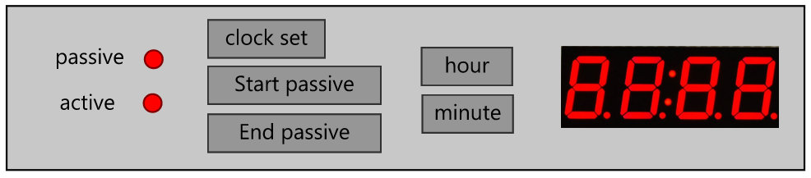

## Figure 7 - Final design - Control Panel Layout

*Mechatronics*

For the microcontroller, we decided to use the ESP32 microcontroller because of its vast capabilities and versatility. This microcontroller can be used as an efficient central processing unit capable of managing system inputs and outputs, sensors, and wireless communication. It is also a relatively fast processor with a speed of 240 MHz, which is more than sufficient for the system we’re planning to run. Additionally, it’s compatible with Arduino and MicroPython, the software that we’ve familiarized ourselves with in previous courses.

We chose our temperature sensors to be thermistors because of their high sensitivity to changes in temperature and their lower costs than alternative devices like thermocouples. Then we need a 7-segment display for our control panel that will display the time that the user selects for the start and stop of the passive cycle.

*Heat sink and ice layers*

For the fin and ice configuration, our group decided on the design shown below in Figure 8 in which there are four layers of fins to enhance heat transfer, along with three layers of ice to maintain the surface temperature at 0 degrees Celsius. For the ice containers, we will be using aluminum rectangular tubing with four individual tubes for each of the three thermal mass layers.

|  |
| --- |

## Figure 8 - Final Design - Heat sink and ice assembly

*Freezer compartment layout*

Since we will be using the freezer section for our thermal mass and passive cycle, we decided to direct airflow with a fan through the middle of the top back panel of the freezer to maximize convection. To further direct and smooth the air flow, we will also be using five vanes and curved sheet metal at the fan opening. The freezer layout for our final design can be found below in Figure 9.

|  |
| --- |

## Figure 9 - Final Design - Freezer layout: Fan placement, vanes, and airflow direction

## 

*Refrigerator interior and return duct*

For our refrigerator’s storage layout, we decided to make use of the current mini refrigerator’s shelving layout such that there are two primary removable shelves with a third shelf that rests above a single removable drawer. The refrigerator’s storage as well as freezer compartment can be seen below in Figure 10.

.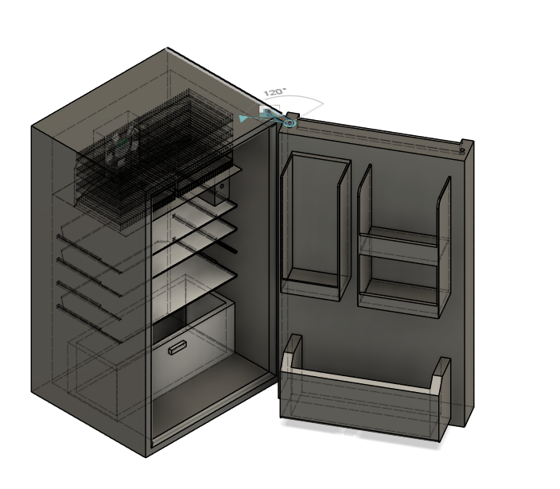

## Figure 10 - Final Design - Mini refrigerator with shelves, drawer, and freezer compartment modifications

The last component of our design solution is the return duct for our passive cycle. First, we will be cutting out the evaporator coil piping and moving the whole evaporator lower, to accommodate our ice casing assembly. We will also be cutting holes on the back of the evaporator to allow airflow up the back of the evaporator for the fan, this is where the return duct will lead. We will be constructing the return duct out of 1/16” Aluminum sheet metal that will be caulked to the inner plastic wall of the fridge to be air-tight. This duct will run from the top of the bottom drawer and up to the fan, as seen below in Figure 11. The fan will draw air from the duct, blow over the ice casings, and be dispersed through the shelves below.

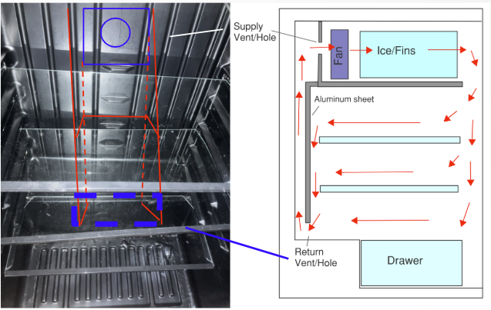

## Figure 11 - Final Design - Return Duct

# Section 2.2: Alternate concepts considered

Our alternative design concepts were divided into design sections of heat transfer, shelf placement, control panel, and fan placement, since these were the areas where we had the most variation.

For heat transfer, it was mainly based on the placement of the fins and ice block on the refrigerator, which we had 5 different designs shown in Figure 12. Designs 1 and 2 have the fins and ice block placed in the freezer compartment of the refrigerator, the difference being that design 1 uses one large slab of ice while design 2 uses several thin layers of ice. Designs 3 through 5 have the freezer compartment located in the back of the fridge. Design 3 is similar to design 2, using layers of thin ice, with the main difference being the vertical placement of the fins. Designs 4 and 5 are similar in design, having the fins horizontal instead with design 4 having rectangular tubes while design 5 has cylindrical tubes.

### 

| Design 1 | Design 2 | Design 3 | Design 4 | Design 5 |
| --- | --- | --- | --- | --- |
|  |  |  |  |  |

## Figure 12 - Fin/Block Placement

For the control panel, we planned to have a simple setup where the user could see whether or not the refrigerator is on the active or passive cycle, and the ability to toggle it on or off. We considered three different placements with a display on the front door, above the fridge door, or inside the fridge, as shown in Figure 13. Also, temperature adjustment or display controls were considered in making the layout for the panel.

### 

| Design 1 | Design 2 | Design 3 |
| --- | --- | --- |
|  |  |  |

## Figure 13 - Control Panel placement

## 

Figure 14 below displays three possible layouts for the return duct, fan, and ice casing assembly. Some of the design parameters we had in mind were trying to maximize the size of the ice casing assembly, as well as efficient airflow so as to not require too much static pressure for our fan. In these diagrams, the red rectangle represents the return duct opening, and the blue arrows are the projected airflow through the ice block and fins. These design concepts are all based on Design 2 from above in Figure 12 - Fin/Block Placement.

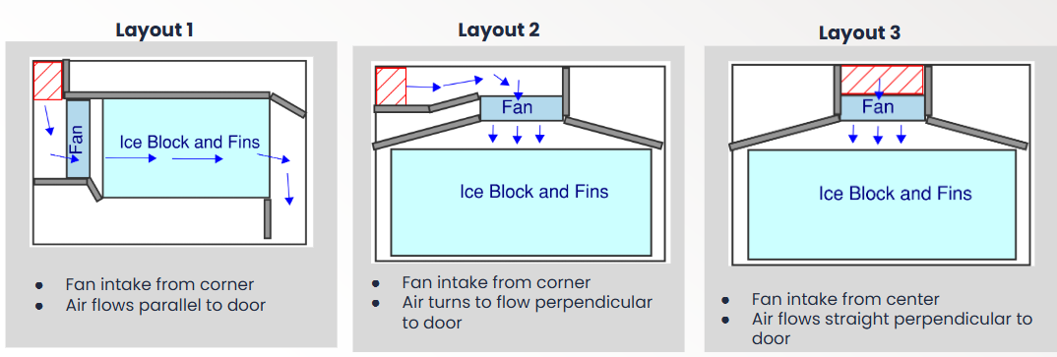

## Figure 14 - Freezer Design Concepts

# Section 2.3: Concept Selection

Our design selection process came down to two metrics: cost to manufacture and adequate cooling. We used a pugh chart, listed in Table 1, to list the pros and cons of each ice casing design, which can be seen below. The criteria we evaluated for each possible fin configuration were based on their ice freezing rate, fin surface area, manufacturability, use of space, and static pressure. After going through the Pugh chart, as well as performing the calculations for fan CFM, ice volume, and fin surface area in Section 3.2, it was clear that design 2 was the best option. After choosing Design 2, we then compared several different heat sinks and varied the layers of ice to best fit our refrigeration system.

### 

### 

### Table 1 - Pugh Matrix for Heat Transfer Shapes

| **Criteria** | **Baseline/**  **Datum** | **Design 1** | **Design 2** | **Design 3** | **Design 4** | **Design 5** |
| --- | --- | --- | --- | --- | --- | --- |
| Ice freezing rate | 0 | 0 | +1 | -1 | +1 | -1 |
| Fin Surface Area | 0 | -1 | +1 | +1 | +1 | 0 |
| Manufacturability | 0 | +1 | +1 | +1 | 0 | -1 |
| Efficient Use of Space | 0 | +1 | +1 | +1 | 0 | 0 |
| Airflow Pattern/Static Pressure | 0 | +1 | +1 | +1 | -1 | -1 |
| Total |  | 2 | 5 | 4 | 1 | -3 |
| Rank |  | 3rd | 1st | 2nd | 4th | 5th |

For deciding our control panel location and interface, we had an open discussion on what format we had in mind that would be easy to use, easy to program, and easy to manufacture. We also took into account our customers' needs survey and decided that temperature adjustment is low on priority, so we can make our control panel and code as simple as possible. Our full customer needs survey can be found in Appendix E as Table 12.

Detailed calculations and a heat transfer spreadsheet simulation were used to choose the specific heat sink and determine the amount of ice required in our heat sink and ice assembly. We also calculated the pressure drop for our system curve for the fan selection that we chose to be able to model what CFM we need for our ice casing assembly. The heat sink and pressure drop calculations that justify our chosen design are explained in detail below in Section 3.2.

Our concept selection for fabrication was based on our group's experience and confidence in different manufacturing processes, what equipment we had access to, the cost to fabricate and manufacture each component, and how effective each component needs to be at its role. Some of our group members have access to 3D printers, which will be very helpful. One of our group members has experience with MIG welding, as well as access to a friend’s welder. As a group, we ranked each manufacturing process based on how confident we were in it, as well as if we thought it would perform in our project. Some of the manufacturing processes we evaluated were welding, 3D printing, brazing, glueing, tacking, screwing/nailing, CNCing, and plasma cutting.

# Section 3.1 - Theoretical Background

This project relates to concepts from thermodynamics, heat transfer, fluid dynamics, and mechatronics. Thermodynamics and heat transfer concepts are used to describe the conservation and transfer of heat throughout the refrigeration system. The active loop of the refrigerator operates with a vapor compression cycle in which refrigerant changes in pressure, temperature, and as a result phase as it travels through the refrigerator and moves the heat from inside the freezer chamber to the exhaust into the ambient room.

Like all other commercially available refrigerators, our Smart Refrigerator will utilize the vapor compression cycle during the active cooling mode. The mini refrigerator that we are retrofitting does not have an evaporator fan. Instead, the air is cooled through the means of natural convection, which occurs due to the density differences caused by the difference in temperature between the air. As the air close to the evaporator coils cools, it will sink lower into the refrigerator while the warm air will rise until it is near the evaporator coil to reduce its temperature as well.

*Thermodynamics*

There are two thermodynamics calculations involved with this senior design project: the energy that must be removed to decrease the temperature of water, and the energy that is used to melt ice. The energy removed from a solid or incompressible liquid can be found using the following equation, where m is the mass (kg), cp is the specific heat capacity at constant pressure (kJ/kgᐧ°C), and $ΔT$ is the change in temperature (°C).

Eq 1. $Q = m c_{p}ΔT$

The energy required to change the phase of a substance is much greater than the energy required to change its temperature. The equation to describe the phase change from water to ice is as follows, where L is the latent heat of fusion (kJ/kg)

Eq 2. $Q = m L$

Eq 2. Q $= \frac{ΔT}{R_{Total}}$

̇

Our passive cooling refrigeration loop during peak hours utilizes forced convection as a fan creates a pressure differential, forcing the air to blow through the ice block and heat sink assembly with a velocity. Both heat transfer and fluid mechanics concepts must be applied to analyze how effectively the passive cooling system delivers cool air to the refrigeration chamber with the purpose of maintaining the temperature less than 37 degrees Fahrenheit.

*Heat transfer*

The first step in determining the heat transfer for forced convection for internal flow is to calculate the volumetric flow per each fin, air velocity, and Reynolds number as per Equation 1 below where V is air velocity (m/s), Dh is the calculated hydraulic diameter (m) and 𝜈 is kinematic viscosity (m2/s)

Eq 3. Reynolds number $Re =\frac{VD_{h}}{ν}$

Next, the flow condition and entry length were determined. For internal flow, the flow can be considered laminar for a Reynolds number less than 2300. Flow is typically considered transitional between 2300 and 4000 and turbulent at greater than 4000. Depending on whether the flow was considered laminar or transitional/turbulent, the entry length was calculated with the respective equation, shown in Table 2, where Pr is the Prandtl number.

### Table 2 - Thermal entry length.

| Laminar | Turbulent (or Transitional) |
| --- | --- |
| $L_{t, laminar}=0.05PrD_{h}Re$ | $L_{t, turbulent}=10D_{h}$ |

If the entry length is greater than the depth of the heat sink, the flow is developing, while if it is less than, the flow is considered fully developed. Based on the laminar/turbulent and developed/developing flow conditions, the corresponding equation for Nusselt Number is chosen as shown in Table 7, found below in Appendix A. The heat transfer coefficient can be found using the following relationship, where h is the heat transfer coefficient (W/m2 ᐧ°C) and k is the thermal conductivity (W/mᐧ°C).

Eq 4. $Nu = \frac{hD}{k}$

To account for the temperature differential across the fins, the fin efficiency was calculated and included in the provided heat transfer with the following equations where P is the fin perimeter (m), AC is the cross sectional area per fin channel (m2), and L is the length of the heat sink that the air is blowing across (m).

Eq 5. Fin efficiency: $η = \frac{tanh(mL)}{mL}$ Eq 6. $m=\sqrt{\frac{hP}{kA_{c}}}$

The provided heat transfer is calculated using Logarithmic mean temperature difference and the convection heat transfer equation below, where As is the total surface area of including all of the fins (m2). Finally, this provided heat transfer can be compared to the required heat transfer determined from the grocery load simulation, 51 W.

Eq 7. $ΔT_{LMTD }= \frac{{ΔT}_{1}- {ΔT}_{2}}{ln \left(\frac{{ΔT}_{1}}{{ΔT}_{2}}\right)}$ where ${ΔT}_{1}=T_{inlet}- T_{base}$ and ${ΔT}_{2}=T_{outlet}-T_{base}$

Eq 8. Q̇ = $ηhA_{s}ΔT_{LMTD }$

*Fluid Mechanics*

As air flows through a channel, there will be pressure loss due to both the friction between the air and the surface as well as the turbulence that occurs in transitions, including turns, enlargement, and contraction. The path that the air must take in our mini refrigerator is shown below in Figure 15. In our application, the pressure loss due to transitions will be several magnitudes larger than the pressure loss due to friction, so we will only be considering the transitions in our calculations.

## 

## Figure 15 - Path of airflow for passive cooling cycle

The pressure drop due to transitions can be found with the following equation, where K is the loss coefficient that is specific to a given transition and found using Figures 22 and 23 found below in Appendix A.

Eq. 9 $ΔP =K\frac{ρV^{2}}{2}$

# Section 3.2 – Analysis

*Ice Block Calculation*

The total volume of ice required can be calculated based on the sum of the energy lost during the passive cooling period and ice properties using the heat equation for change of phase, Equation 2. Using the sum of the load during the passive cooling period from our load simulation, 545 kJ, the volume of ice can be calculated as follows.

$Q = m L$

$m = \frac{Q}{L} = \frac{545 kJ}{334 \frac{kJ}{kg}} =1.63 kg$

$V = \frac{m}{ρ} =\frac{1.63 kg}{917 \frac{kg}{m^{3}}}=0.0018 m^{3} =109 {in}^{3}$

*Heat sink heat transfer selection spreadsheet*

The most important specification of our Smart Refrigerator is that it is able to properly regulate the temperature of the storage chamber, such that the food doesn't spoil. The standard for refrigeration of food is between 35-40 degrees Fahrenheit. Our chosen target temperature was 37 degrees Fahrenheit, which is reflected in our simulated grocery load shown in Figure 4 of Section 1.3. The average load during the passive period, 51 W, is the target heat transfer rate that ensures that our refrigerator is able to maintain refrigeration and uphold this standard. Though this average load is used in our calculations, the passive system will be responding to the instantaneous load by controlling the speed of the fan.

To simulate the provided heat transfer for various heat sinks and air flow rates, we created a tool in Google Sheets that takes inputs for the heat sink fin spacing, thickness, and height as well as the length and width of the ice block configuration and the number of layers. The spreadsheet uses these inputs to calculate the actual heat transfer that occurs at a given air volumetric flow rate and compare it to our target heat transfer rate, 51 W. This allows us to first determine which fin spacing, thickness, and height delivered the best heat transfer rate, then determine how many layers of ice were required for a reasonable air flow rate and resulting pressure drop that a small fan could provide and overcome. An example output table of the spreadsheet can be found below in Table 3. All properties of air, water, ice, and aluminum used in the calculations can be found below in Table 9 in Appendix A.

### Table 3 - Example output table from heat sink simulation spreadsheet

| **volumetric flow (CFM)** | **20** | **30** | **50** | **55** | **60** | **70** |
| --- | --- | --- | --- | --- | --- | --- |
| V_dotTotal (m^3/s) | 0.00944 | 0.01416 | 0.02360 | 0.02596 | 0.02832 | 0.03304 |
| Mdot Total (kg/s) | 0.01215 | 0.01822 | 0.03037 | 0.03340 | 0.03644 | 0.04251 |
| V_dotPer fin (m^3/s) | 0.0000433 | 0.0000650 | 0.0001083 | 0.0001191 | 0.0001299 | 0.0001516 |
| MdotPer fin (kg/s) | 0.000056 | 0.000084 | 0.000139 | 0.000153 | 0.000167 | 0.000195 |
| Vair (m/s) | 0.408 | 0.612 | 1.020 | 1.122 | 1.224 | 1.427 |
| Re | 295 | 442 | 737 | 811 | 885 | 1032 |
| Flow | L | L | L | L | L | L |
| Entry Length | 0.156 | 0.233 | 0.389 | 0.428 | 0.467 | 0.545 |
| Developed? | N | N | N | N | N | N |
| Nu | 4.42 | 4.74 | 5.30 | 5.43 | 5.55 | 5.79 |
| h (W/m^2C) | 10.30 | 11.04 | 12.34 | 12.64 | 12.93 | 13.49 |
| m | 4.06 | 4.20 | 4.44 | 4.50 | 4.55 | 4.64 |
| fin efficiency | 88.94% | 88.26% | 87.08% | 86.82% | 86.57% | 86.08% |
| Toutlet (C) | 1.2 | 1.6 | 2.1 | 2.1 | 2.2 | 2.3 |
| (Tbase-Tin) | 5.04 | 5.04 | 5.04 | 5.04 | 5.04 | 5.04 |
| (Tout - Tsurf) | 1.1 | 1.5 | 2.0 | 2.1 | 2.2 | 2.3 |
| Delta T LMTD | 2.6 | 3.0 | 3.3 | 3.4 | 3.4 | 3.5 |
| Qfin, actual (W) | 31.9 | 38.5 | 47.4 | 49.2 | 50.8 | 53.9 |
| Qdot diff | -18.60 | -12.02 | -3.11 | -1.33 | 0.33 | 3.38 |

After the tool was created, we input the heat sink parameters for various heat sink options that were previously researched and determined the minimum average air flow rate required for increasing layers of ice. Then, we put this information into tables for each heat sink in addition to the total height of the heat sink and ice block assembly, as well as the total cost. An example of the table and resulting plot is shown below in Table 4 and Figure 16, respectively. This allowed us to compare the heat sinks side by side with all the necessary criteria for our decision.

### Table 4 - Simulation results for chosen heat sink

| **Layers of Ice** | **CFM** | **Total Height (in)** | **Total Cost** |
| --- | --- | --- | --- |
| 1 | 102 | 2.57 | $39.60 |
| 2 | 100 | 4.36 | $59.40 |
| 3 | 60 | 6.15 | $79.20 |
| 4 | 45 | 7.94 | $99.00 |
| 5 | 34 | 9.72 | $118.80 |

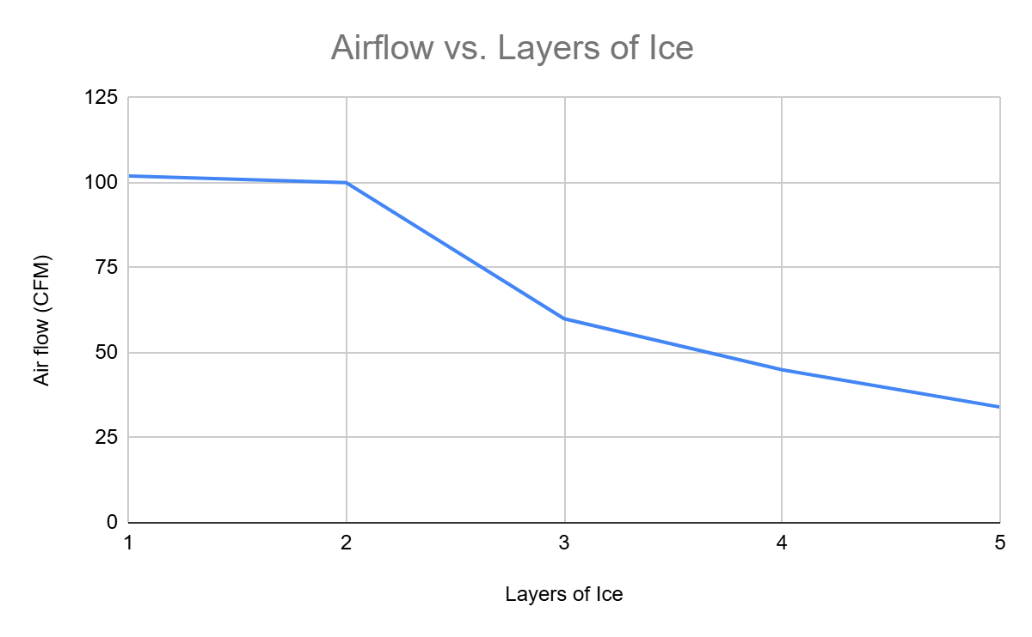

## Figure 16 - Simulation results plotted for chosen heat sink

We chose the heat sink that had the optimal heat transfer and fit within our freezer compartment when compared to six different heat sinks that varied in fin spacing and height. We determined that three layers of ice were required with the chosen heat sink to obtain a reasonable average airflow rate of approximately 60 CFM.

*Pressure drop calculations and fan selection*

Before selecting our fan, we calculated the pressure drop at various air flow rates to create a system curve shown below in Table 5 and Figure 17. Then, we researched fans that had a maximum airflow rate that was about twice as large as our calculated average airflow. This would allow the passive system to respond to larger instantaneous loads and prevent the refrigerated space from exceeding the acceptable temperature range. We considered the fan’s power consumption and size as these were the most important considerations. After choosing the fan that best met these criteria, we plotted the provided fan curve shown in Appendix D against our system curve to ensure that the fan was able to overcome the pressure drop it would encounter. Since the fan curve intersects the fan curve at a greater airflow than the minimum average airflow we calculated previously, we know that the fan will be adequate. We will modulate the fan to lower or higher speeds to meet the instantaneous airflow requirements.

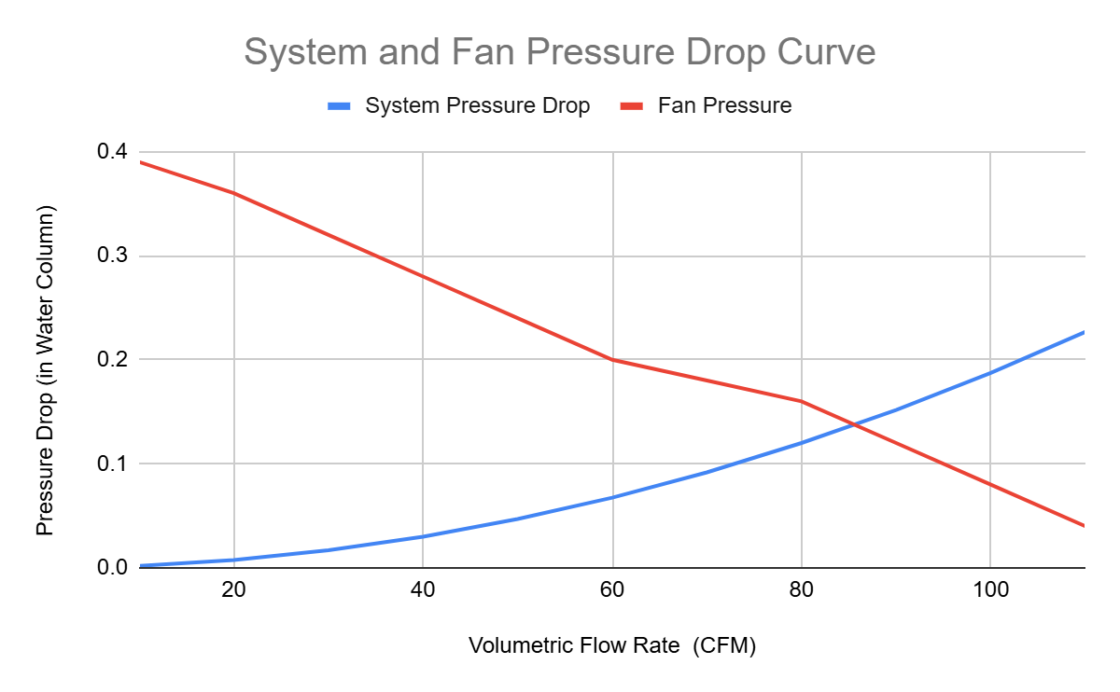

## Figure 17 - System and Fan Pressure Curve

### Table 5 - Pressure Drop Calculations

| **Pressure Drop Due to Transitions Calculations** | | | | | | | |
| --- | --- | --- | --- | --- | --- | --- | --- |
| Description | Percent of total cfm | Assumed cross area (in^2) | Velocity at each point (fpm) | Transition Type | D/D or A/A | Loss coefficient | Pressure Drop (in water) |
| Into Ice + fins | 100% | 0.400 | 1 | Straight | 0.0002 | 0.5 | 0.01 |
| Leaving Ice + fins | 100% | 0.400 | 1 | sudden expansion | 0.01 | 0.6 | 0.01 |
| 90 deg Turn | 100% | 28 | 566 | 90 deg sharp elbow | -- | 1.1 | 0.02 |
| 2 in x 14 in gap | 100% | 28 | 566 | sudden expansion | 0.14 | 0.65 | 0.01 |
| 2 in x 14 in gap | 75% | 28 | 566 | sudden expansion | 0.14 | 0.65 | 0.01 |
| 2 in x 14 in gap | 50% | 28 | 566 | sudden expansion | 0.14 | 0.65 | 0.01 |
| Into Drawer? | 25% | 28 | 566 | sudden expansion | 0.14 | 0.65 | 0.00 |
| Return vent | 100% | 18 | 880 | Return Grille | -- | 0.7 | 0.04 |
| Turn | 100% | 18 | 880 | 90 deg sharp elbow x 2 | -- | 1.1 | 0.06 |
| Turn | 100% | 18 | 880 | 90 deg sharp elbow | -- | 1.1 | 0.06 |
| Input airflow (CFM) | | | 110 | Pressure Drop Total Given Input CFM | | | 0.23 |

# 

# Section 4.1 – Documentation

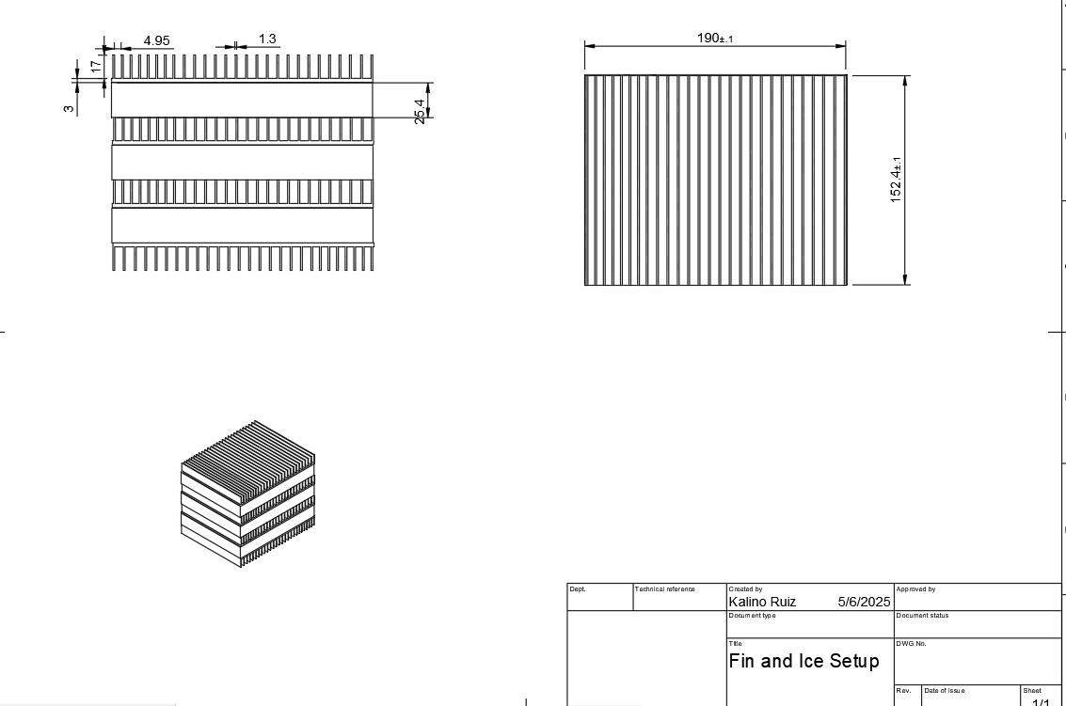

## Figure 18 - Drawing of Ice Block and Fin Setup

In Figure 18, the main dimensions to be toleranced and drawn clearly are on the top view, as that decides how long we wish to cut the store-bought fins. The ice blocks will also be surrounded by thin aluminum piping to store the water/ice.

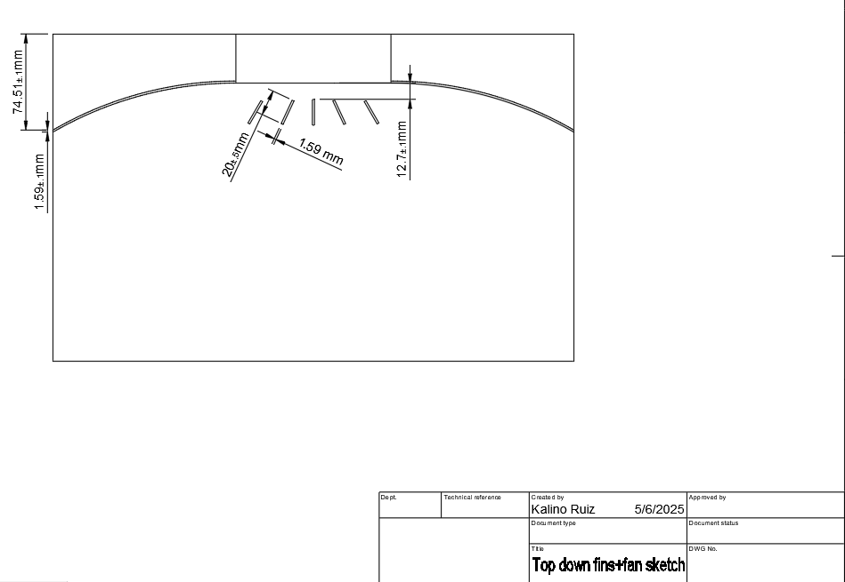

## Figure 19 - Drawing of Vane and Wing Setup for Fan

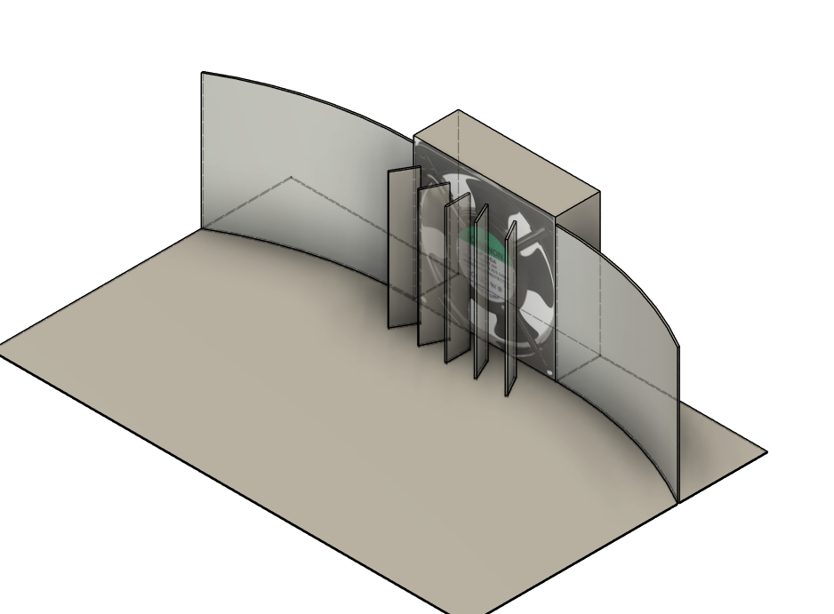

Figure 20 - CAD model of Vanes and Wings with Fan Visualization

## 

As shown above in Figures 19 and 20, vanes are modelled to potentially spread the flow of fan air more efficiently throughout the fins. However, the vanes may be cut in the final design if they prove to make the air too turbulent. The wings are also here to funnel air into the fins.

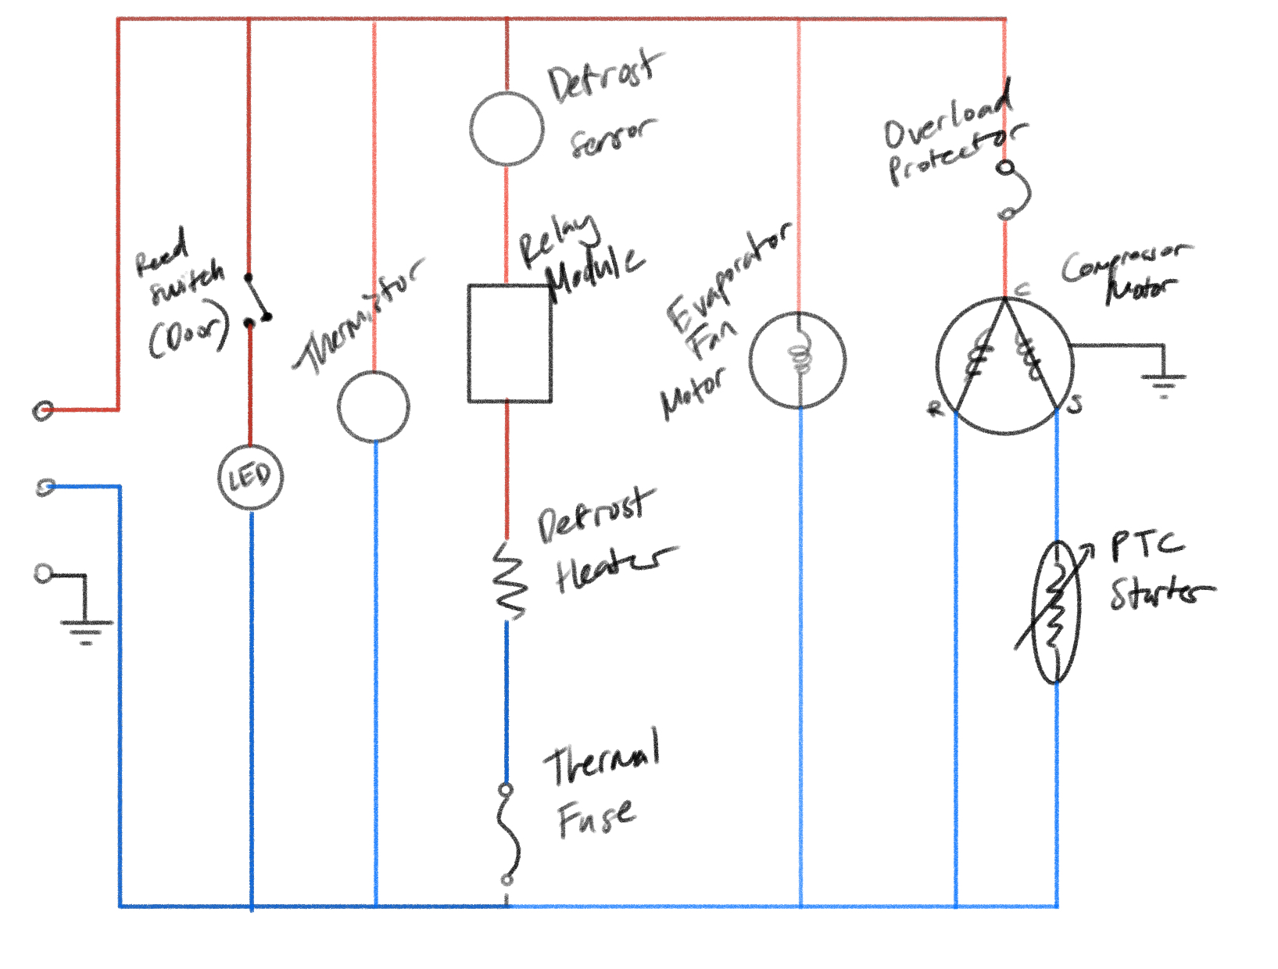

## Figure 21 - Draft of Refrigerator Circuit Diagram

Figure 21 shown above, is the draft of the circuit diagram for the mechatronic components. It consists of the main sensors that we’re either going to add or are already part of the fridge’s components, and the mechanisms such as the evaporator fan and compressor. The data acquisition system we’re going to be using is the ESP32, and for the software, we will be writing our own Python script to control the system.

# Section 4.2 - Bill of Materials and Cost Analysis

### 

### Table 6 - Bill of Materials

| **Component Name** | **MFG#** | **Description/ Purpose** | **Quantity** | **Cost/ Unit** | **Shipping** | **Total** | **Notes** | **Link** |
| --- | --- | --- | --- | --- | --- | --- | --- | --- |
| Fan | SP100A | 4.68 Inch AC Tube Axial | 1 | 13.95 | $ 9.18 | $ 23.13 | Meets CFM requirement | [Link](https://www.jameco.com/z/SP100A-1123XBT-GN-Sunon-120mm-115-VAC-60Hz-Ball-Bearing-Fan-240mA-20W-117-CFM_102884.html) |
| R134a Recharge kit | B09S69H5DP | To pressurize and add pipe length | 1 | 20.99 | $ - | $ 20.99 | Will need can of R-134a | [Link](https://www.amazon.com/FANOVO-Refrigerator-Recharge-Refrigerant-Self-Sealing/dp/B09S69H5DP/ref=asc_df_B09S69H5DP?mcid=3db2c85207a63eabbaad7770746b1fe6&hvocijid=11630531409563374806-B09S69H5DP-&hvexpln=73&tag=hyprod-20&linkCode=df0&hvadid=721245378154&hvpos=&hvnetw=g&hvrand=11630531409563374806&hvpone=&hvptwo=&hvqmt=&hvdev=c&hvdvcmdl=&hvlocint=&hvlocphy=9032170&hvtargid=pla-2281435178618&th=1) |
| R-134A | SER134A | Pure R-134A | 1 | 14.00 | $ 11.32 | $ 25.32 |  | [Link](https://coldhose.com/products/r134a-refrigerant-12oz-can?variant=35532320014496) |
| Copper Pipe | 630456606893 | Refrigerant Piping 3/8" OD | 1 | 16.99 | $ - | $ 16.99 | 5 Feet of tubing | [Link](https://www.amazon.com/GOORY-Copper-Tubing-0-328-Refrigeration/dp/B0DKT3JDPT/ref=sr_1_4?crid=166OUAN102SU1&dib=eyJ2IjoiMSJ9.zoREXYMGDBq5lJJB70XHOHAROllLmtIDXSfTp1eMPC-vE5oAG35L-xflnz-svtKtyTs2h-LEhTuAPAawieOadNjOIwJ4ZMtNYMM1q-if-aZqf6dVr7FLy4rg0_q3QAbFXV7Ia-u-BZkT_zgJzpIAgUO2lMH29FlzukkA3BVIKqIO7j51gVL145T5qqX673QUMUG-bMeMX4wasBRXTmdoUSRXFpqLuiruVhObH2Nq2Ac.F07vywvrQYbg-Jypd4QmIxJm9RvZFZgQPeFRbMg0ZJU&dib_tag=se&keywords=copper%2Brefrigerant%2Bpiping&qid=1745992492&sprefix=copper%2Brefrigerant%2Bpipin%2Caps%2C377&sr=8-4&th=1) |
| Heatsink | 64AS | 7.874'' (200mm) Wide Heatsink (64AS) | 8 | 9.90 | $ 12.36 | $ 91.56 | 7.9" x 6" | [Link](https://heatsinkonline.com/products/7874-wide-heatsink-64as?variant=42105916653730&country=US&currency=USD&utm_medium=product_sync&utm_source=google&utm_content=sag_organic&utm_campaign=sag_organic&utm_campaign=gs-2022-07-05&utm_source=google&utm_medium=smart_campaign&gad_source=4&gbraid=0AAAAABmrCYdmSs6RRO8d2MZDT69-jNeqJ&gclid=CjwKCAjwq7fABhB2EiwAwk-YbNJNHDVNKmhC6NEKsVn3wKhq0ggWOAc9W3ACV31yxpUNhxtY-Ju1OxoCGtAQAvD_BwE) |
| Temperature Sensor | ERP 2188820 | Refrigerator Thermistor | 2 | 11.00 | $ - | $ 22.00 |  | [Link](https://www.amazon.com/ER2188820-ERP-Thermistor-Replaces-2188820/dp/B01M8OFHHX) |
| Display | TM1637 | 4 Digit 7 Segment Display | 1 | 3.95 | $ 4.09 | $ 8.04 |  | [Link](https://www.jameco.com/z/TM1637-JVP-Jameco-ValuePro-TM1637-4-Bits-Digital-Red-LED-Display-Module-for-Arduino-7-Segment-0-36-4-Digit-Clock-Anode-Serial-Driver-Board_2325423.html?CID=GOOG&utm_source=google&utm_medium=ppc&utm_campaign=&utm_term=&utm_content=&gad_source=4&gad_campaignid=17336645193&gbraid=0AAAAADoyMrdTfjL0XWHlsPpaIKEPx7iFT&gclid=Cj0KCQjwlMfABhCWARIsADGXdy-5ZPRjeSekmAhkRNRcc-6NoqRiyiN0gZbNljShqVxzSGMeHSO1yvcaApfOEALw_wcB) |
| Buttons | EK1019 | 6x6x4.3mm TACT Switch Push Button | 1 | 6.98 | $ - | $ 6.98 | (pack of 50) Purchasing separately | [link](https://www.amazon.com/Gikfun-6x6x5mm-Switch-Button-Arduino/dp/B00R17XUFC?source=ps-sl-shoppingads-lpcontext&ref_=fplfs&psc=1&smid=A34K5WF5Z9R33P&gQT=2) |
| Aluminum Tube | T34118 | Ice casings | 12 | 9.30 | $ 41.00 | $ 152.60 | 4x1x1/8"x6  Note this shipping rate covers both the tube and sheets | [Link](https://www.metalsdepot.com/aluminum-products/aluminum-rectangle-tube?product=290) |
| Sheet Aluminum | S3063 | Ice Casings/ controlling airflow | 2 | 42.72 | $- | $ 85.44 | 24"x24"x1/16" | [link](https://www.metalsdepot.com/aluminum-products/aluminum-sheet?product=381) |
| Microcontroller | ESP32 | Control the Fridge | 0 | 8.00 | $ - | $ - | Already owned | [link](https://www.espressif.com/en/products/socs/esp32) |
| Mini Fridge | SNFSR3770S | Have on hand already | 1 | 0.00 | $ - | $ - | Is not currently working | [link](https://www.officesupply.com/cleaning-breakroom/breakroom-supplies/breakroom-appliances/refrigerators/sanyo-3770s-refrigerator/p2717.html?srsltid=AfmBOoo5z1bY3i-V0VQkeaajiMKQmAH2HW7OOxfM1yVMyCvim8zrq45G) |

In the table above is our BOM with all of the components we hope to purchase, as well as a few parts we already have on hand but are necessary for the construction of our project. We chose our components as if we had to purchase them with our own money. There is nothing frivolous, but we did our best to choose the highest quality components. We spent a lot of time calculating the exact ice volume and fin surface area to maximize the amount of cooling we can produce, while taking up the least amount of internal volume. The full calculations are listed in Appendix A. There were cheaper materials available for certain components, such as 3D printing our ice casings or return duct. However, PLA filaments do not conduct heat well, and especially for the fin casings, it is imperative that we can get the most amount of heat transfer possible, so for this reason, we went with aluminum. It is known that copper is the best at conducting heat, but as a group, we decided copper casings or heat sinks are out of our budget, and are also more difficult to fabricate.

If our design were to go into production, we believe that our cost per unit would go up. The primary reason for this is that one of our group members already had a mini fridge on hand. But if we were to produce more units, we would need to acquire more mini fridges, which would drive our cost per unit up. However, outside of acquiring the fridge, the rest of our costs would go down. The biggest costs in this project, outside of the fridge, are our aluminum piping and sheet metal. First and foremost, shipping the aluminum costs quite a lot. If we were to mass produce our product, we could order in bulk and save on shipping. Another way our costs would go down would be by utilizing our sheet metal. We are only building one unit, so when it came to ordering sheet aluminum, we bought extra sheet metal to make sure we have enough. As we produce more units, we can use the sheet aluminum more efficiently, saving money. The same principle applies with the copper piping; we only need a very short length of piping in our design, but the 5-foot length was the smallest denomination we could order. All in all, our fabrication costs would go down per unit, but the overall price per unit would go up to account for acquiring mini fridges.

# 

# References

Edinger, M. (2021, May 14). PG&E and other utility companies automatically changing rate plans. Here’s how to opt out. KMPH. https://kmph.com/news/local/gallery/pge-and-other-utility-companies-automatically-changing-rate-plans-heres-how-to-opt-out?photo=1

EIA’s residential energy survey now includes estimates for more than 20 new end uses. (n.d.). Www.eia.gov. https://www.eia.gov/todayinenergy/detail.php?id=37813

Garber-Slaght, R. (2013, March). Passive Refrigeration. Cold Climate Housing Research Center; CCHRC. <https://cchrc.org/wp-content/uploads/media/passiverefrigeration.pdf>

U.S. Bureau of Labor Statistics. (2025, March 1). Electricity Per KWH in U.S. City Average. FRED, Federal Reserve Bank of St. Louis. https://fred.stlouisfed.org/series/APU000072610

Sustainable Transformation: Trane’s Thermal Energy Storage System at 11 Madison Avenue,

NYC. (2024). Trane. <https://www.trane.com/commercial/north-america/us/en/about-us/newsroom/case-studies/commercial-real-estate/11-madison-avenue0.html>

# 

# ‌Appendix A: Detailed Calculations

### Table 7 - Nusselt number depending on flow condition

|  | Laminar | Turbulent |
| --- | --- | --- |
| Developed | Refer to Table 8 | $Nu = 0.023{Re}^{0.8}{Pr}^{0.4}$ |
| Developing | $Nu = 3.66+\frac{0.065(D/L)RePr}{1 +{ 0.04[(D/L)RePr]}^{2/3}}$ | $Nu = 0.023{Re}^{0.8}{Pr}^{0.4}$ |

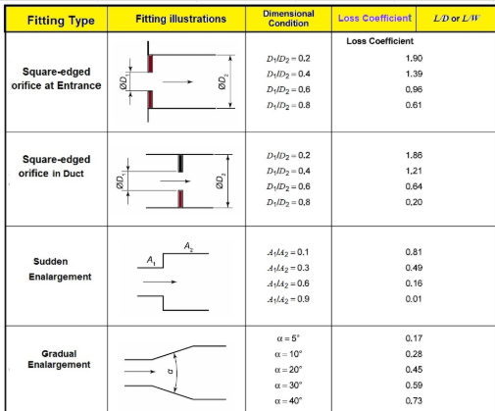

## Figure 22 - Loss coefficient due to expansion and contraction

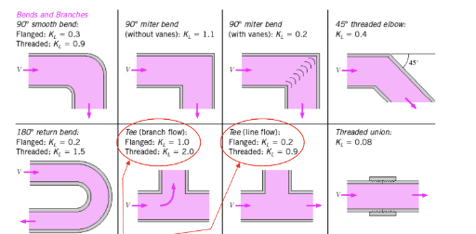

## Figure 23 - Loss coefficient due to bends

### Table 8 - Nusselt number for constant surface temperature given width a and height b

| a/b | Nu |
| --- | --- |
| 0.1 | 2.61 |
| 1 | 2.98 |
| 2 | 3.39 |
| 3 | 3.96 |
| 4 | 4.44 |
| 6 | 5.14 |
| 8 | 5.6 |

### Table 9 - Water, ice, and air properties

| Water Properties | | |
| --- | --- | --- |
| Description | Value | Variable |
| Specific heat of water (kJ/kgC) | 4.184 | cp_wat |
| Density of water at 20 C (kg/m^3) | 998.2 | dens_wat |
| Ice Properties | | |
| Description | Value | Variable |
| Specific heat of ice (KJ/kgC) | 2.06 | cp_ice |
| Density of Ice (kg/m^3) | 917 | dens_ice |
| Latent heat of fusion (kJ/kg) | 334 | Latent_ice |
| Thermal conductivity of ice (W/mK) | 2.22 | k_ice |
| Air properties | | |
| Description | Value | Variable |
| Specific heat of air (KJ/kgC) | 1.005 | cp_air |
| R value of air (kJ/kg) | 0.287 | R_air |
| Atmospheric pressure (Pa) | 101.325 | P_atm |
| Kinematic Viscosity - v (m^2/s) | 0.0000146 | kin_vis_air |
| Dynamic Viscosity - mu - (Ns/m^2) |  | dyn_vis_air |
| Prandtl | 0.71 | Pr |
| Thermal conductivity of air (W/mk) | 0.02459 | k_air |

### Table 10 - Shell surface area and heat transfer through walls calculation

| Surface Area Outer Shell |  |
| --- | --- |
| Height (in) | 31.75 |
| Depth (in) | 18 |
| Width (in) | 18 |
| Height (m) | 0.81 |
| Depth (m) | 0.46 |
| Width (m) | 0.46 |
| Sides area (m^2) | 0.369 |
| Top area (m^2) | 0.209 |
| Front/back area (m^2) | 0.369 |
| Total Outer surface area (m^2) | 1.684 |
| Surface Area Inner Shell |  |
| Height (in) | 29 |
| Depth (in) | 15.5 |
| Width (in) | 14 |
| Height (m) | 0.7366 |
| Depth (m) | 0.3937 |
| Width (m) | 0.3556 |
| Sides area (m^2) | 0.28999942 |
| Top area (m^2) | 0.13999972 |
| Front/back area (m^2) | 0.26193496 |
| Total Inner Surface Area | 1.244 |
| Heat transfer through walls calculation | |
| Insulation thickness - L (m) | 0.05 |
| Estimated k value (W/mC) | 0.36 |
| Interior h value (W/m^2C) | 10 |
| Exterior h value (W/m^2C) | 10 |
| Rconv, interior air | 0.080 |
| Rcond, insulation | 0.234 |
| Rconv, exterior air | 0.059 |
| Rtotal | 0.374 |
| Q_dot (W) | -49.0 |
| Q_dot (kW) | -0.049 |

### 

### Table 11 - Inputs and preliminary calculations for heat transfer simulation spreadsheet

| **Length and Depth of Fin** | |
| --- | --- |
| Length of block (in) | 6 |
| Depth of block (in) | 15.748 |
| Length of block (m) | 0.15 |
| Depth of block (m) | 0.40 |
| Area of block (m^2) | 0.061 |
| **Fin Parameters** | |
| Layers of ice | 3 |
| Height of fins (in) | 0.669 |
| Fin thickness (in) | 0.043 |
| Fin spacing (in) | 0.246 |
| Height of fins (m) | 0.017 |
| Fin thickness (m) | 0.0011 |
| Fin spacing (m) | 0.006 |
| Number of fins | 218 |
| a/b (spacing/height) | 0.4 |
| Cross sectional area PER FIN (m^2) | 0.000106 |
| Channel Perimeter PER FIN (m) | 0.040 |
| Hydraulic diameter (m) | 0.0106 |
| Total surface area (m^2) | 1.34 |

### 

# Appendix B: Detailed simulation results and computer programs

Note that the spreadsheet used for the fin heat transfer calculations is essentially our detailed simulation and the results are provided in Section 3.2

# 

# Appendix C: Detailed design Drawings

## 

## Figure 24 - Drawing of Ice Block and Fin Setup

## 

## 

## Figure 25 - Drawing of Vane and Wing Setup for Fan

## 

## Figure 26 - CAD model of Vanes and Wings with Fan Visualization

## 

# 

# Appendix D: Excerpts from datasheets of components

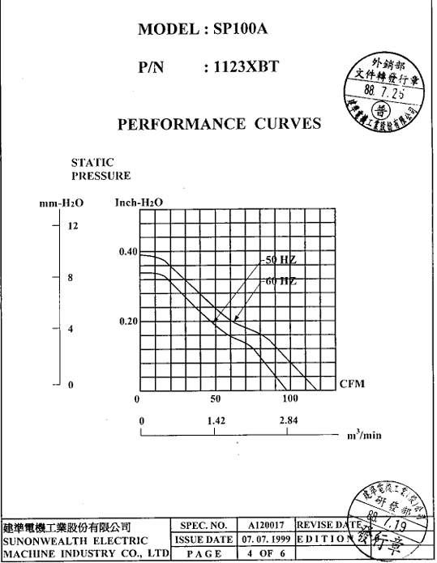

## Figure 27 - Fan performance sheet

# Appendix E: Customer Needs Survey

### Table 12 - Customer Needs Survey

